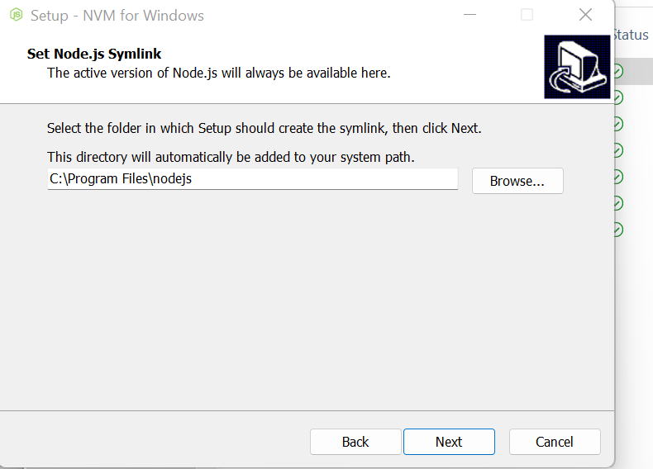

[How to completely uninstall Node.js and npm from Windows | Reactgo](https://reactgo.com/uninstall-node-npm-from-windows/#:~:text=1%20Go%20to%20the%20windows%20control%20panel%20and,npm%20are%20completely%20uninstalled%20from%20your%20system%20using%3A)